Question-8 Scenario: Linux Administrator You have just joined a company as a Linux System Administrator. Your boss has assigned you a series of tasks to test your command-line skills and understanding of Linux systems. Complete the following tasks and submit the command logs and explanations for each step.
Task 1: Setup Project Directory & Files: 1. Create a directory /home/yourusername/project 2. Inside project, create three files: app.log, config.cfg, and data.csv 3. Write some sample text in config.cfg (e.g. mode=production) 4. Display the contents of config.cfg
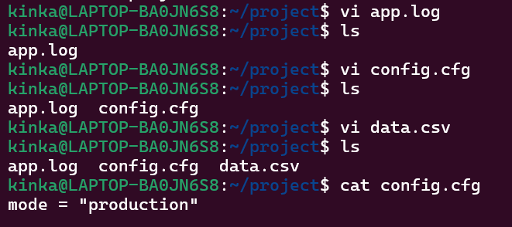
Task 2: Manage File Permissions : 1. Set app.log to be writable only by the owner 2. Set config.cfg to be readable by everyone but writable only by the owner 3. Set data.csv to be readable and writable by everyone (for testing) 4. Show commands used and output of to verify permissions.
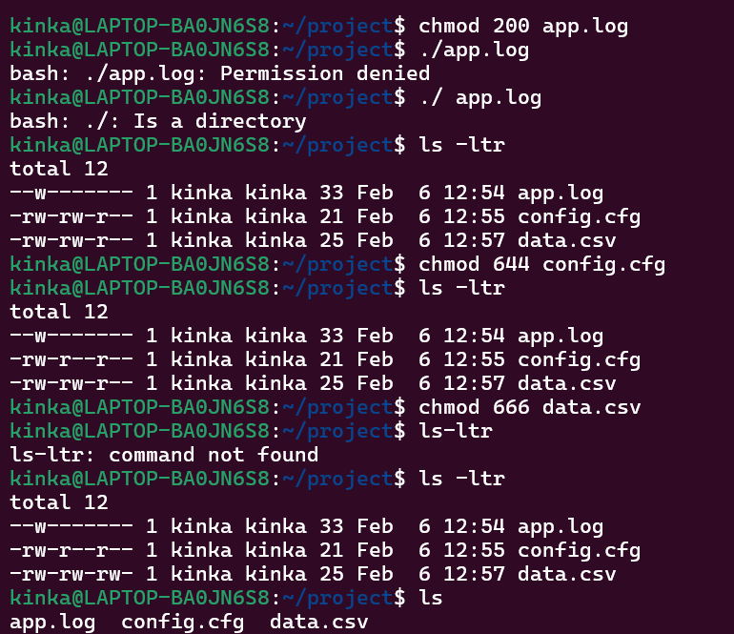
Task 3: User and Group Management (Simulated) 1. Create a new user devuser (you can simulate this if no root access) 2. Create a group developers 3. Add devuser to the developers group 4. Change group ownership of /home/yourusername/project to developers 5. Allow group members to write inside the project directory.

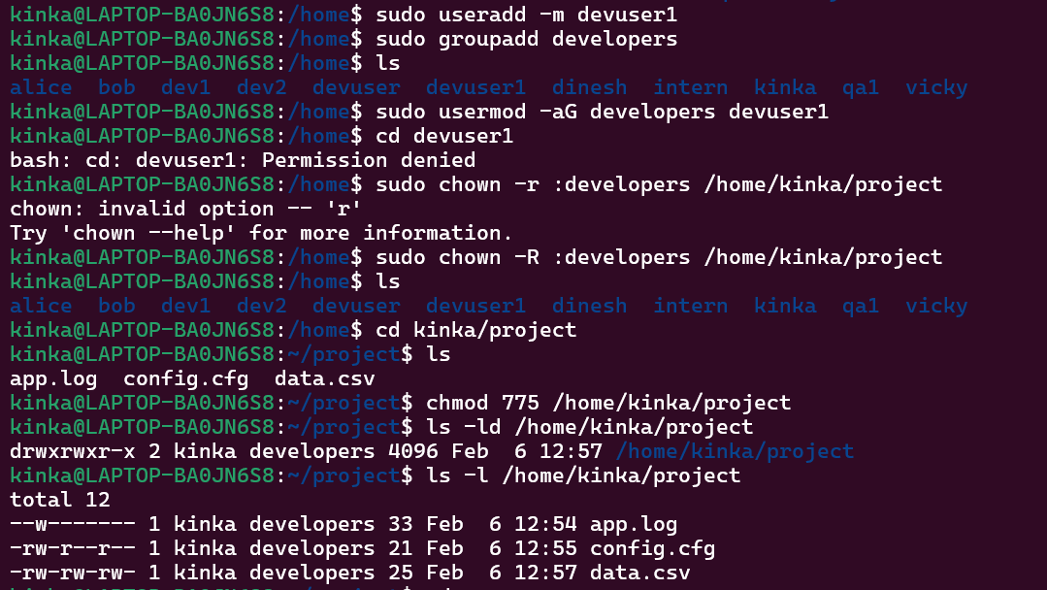
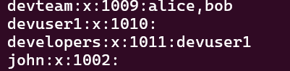
Task 4: Collaborative Script Writing and Execution: 1. User yourusername creates a shell script in the shared project directory. 2. User devuser (in the developer group) should be able to read and execute that script.(you can write simple script like (Deploying project...and date)
Commands used:
sudo mkdir -p /shared/project
getent group developer
sudo groupadd developer
sudo usermod -aG developer devuser
groups devuser
sudo chown :developer /shared/project
sudo chmod 770 /shared/project
ls -ld /shared/project
drwxrws---
vi /shared/project/deploy.sh
#!/bin/bash
echo "Deploying project..."
date
chmod 750 /shared/project/deploy.sh
ls -l /shared/project
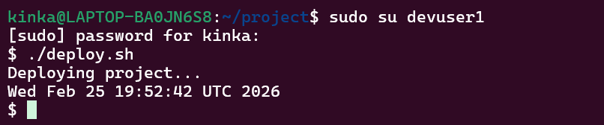

Task 5: Process Monitoring: 1. Check the current running processes related to ssh or sshd 2. Use commands like ps, top, or htop (if installed) 3. Find the process ID (PID) of sshd 4. Show how to kill the process safely (simulate this step if needed)

Task 6: Viewing Logs: 1. View the last 10 lines of system log files (e.g. /var/log/syslog or /var/log/messages depending on your distro) 2. Use tail and grep to find entries related to ssh

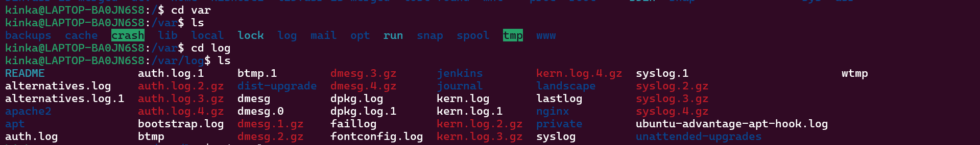
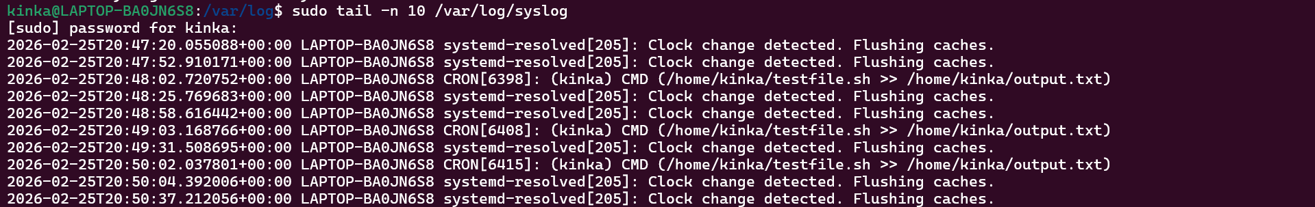

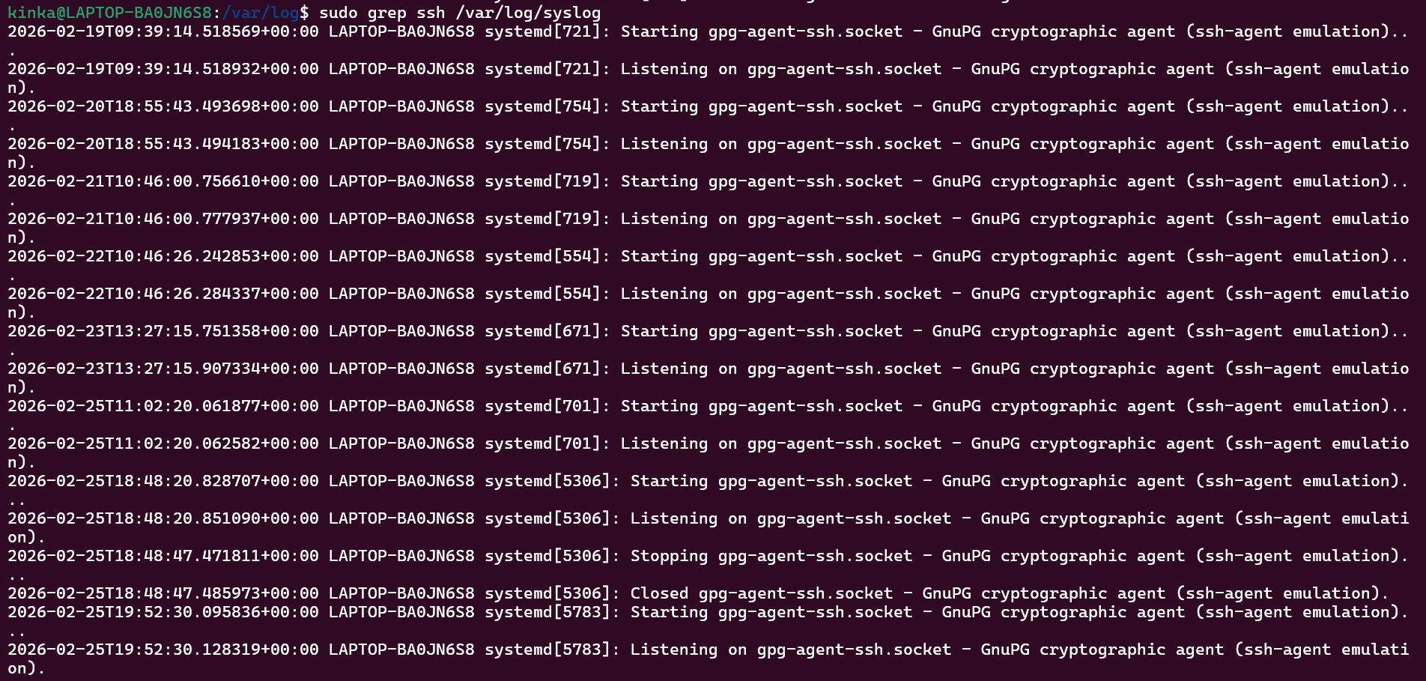
Create a Shell Script 1. Write a bash script check_project.sh that: 2. Prints the current date/time 3. Lists files in /home/yourusername/project with details 4. Prints the disk usage of the home directory Here i provide shell script you just want to run it - ( #!/bin/bash echo "Current Date and Time: $(date)" echo "Files in project directory:" ls -l ~/project echo "Disk usage of home directory:" du -sh ~/ )

